6/14/2019

Adeel Asghar

SDD – Mr. Anderson

HSC Assessment Task 3

Software Design and Development

# Declaration

Within this assessment task I aim to produce a fully functioning program which creates a close passage within itself through text input or file upload, displays the cloze passage with missing words and the word bank on the side and allows the cloze passage to either be completed within the program itself or to be saved within the device so it can be printed later.

I will design the program within Visual Studio using VB as the language and submit as a zipped folder with all documentation to support by the due date.

# Defining and Understanding the Problem

**Requirements**

**Needs of the teacher**

Within the program, the teacher must be able to design the cloze passage by either inputting text into a textbox or by importing a .txt or .docx file and then display the cloze passage with words missing and a word bank made available for the student to either complete within the program or to save it as a pdf. file to be printed at a later date. The program must also not allow the students to view the original text to ‘cheat’ in completing the cloze passage.

**Needs of the student**

Students require to have a cloze passage be displayed within the program window with blank spaces where words should be and a word bank which allows them to complete the passage within the program itself.

**Functionality list**

The functionality requirements that my program must meet include:

* The user can input their own text into a textbox to use to create the cloze passage
* The user can import .txt or .docx files to use as the text for the cloze passage
* The user can decide how many words are removed within the final cloze passage (every *n*th word)
* Understands how many words are within the entered or imported text to determine which words to remove and store
* Stores the word individually to determine which words to remove
* The final cloze passage should display in a new form with every *n*th word removed and replaced with an underline
* A word bank should display with all the removed words within
* The user is able to save the final cloze passage as a .pdf file to be able to print it out later
* The user can complete the cloze passage within the program itself by selecting words within the word bank and inserting them into each blank space from the passage.
* Removed words are stored and can be called on when completing the cloze passage

**Compatibility issues**

My program is expected to work on the following platforms:

* Different Operating Systems; MacOS and WindowsOS.
* Different screen sizes
* Different form sizes
* Varying storage capabilities

**Performance issues**

The performance of my program will be justified based on its:

* Processing of selected missing words
* Efficiency of storing and displaying removed words
* Ease of transition between pages
* Carriage of cloze passage and word bank throughout each form within an array

**Social and Ethical Issues**

There are numerous social and ethical issues which I was required to consider when designing the interface and the overall program, including:

* User friendliness; By designing my program in a straight-forward and easy to follow procedure I have enabled it to be very user-friendly; through large text and self-explanatory processes displayed.
* Inclusivity; By using neutral colours, free software and allowing unrestricted access to features I have been able to make my program inclusive for all populations regardless of age, ethnic background, socio-economic status and culture.
* Copyright; Considering my program has been produced as an assignment submission there are no copyright restrictions enforced which gives users full access to manipulate and publish my work for their profit.
* Piracy; I have ensured not to use any pre-made code from other sources such as completed programs or from secondary sources to process main subs within my program. I have only used sections of code provided to me by the teacher.
* Design decisions; I have decided on designing the user interface in the way it is to conform to simplistic and easy to follow procedures to ensure user-friendliness. And ease of use.
* Ergonomics; The flow of processes to complete my program has been made easy with large buttons and clear instructions.
* Privacy; No personal information is stored within my program to ensure maximum user safety. The cloze passage is stored onto the user’s device without asking for permission prior which may raise awareness of security at a small risk.

**Quality Assurance Methods**

Quality assurance is a set of procedures used to certify that a generated product meets specified criteria with respect to quality and reliability. The quality of a software product is measured against how well the product meets of exceeds user expectations. The 11 quality assurance factors are as follows:

Correctness; My program satisfies the criteria to produce a program which allows the use to type or import a section of text used to create a cloze passage which could either be saved onto the device in a printable file type or to be completed within the program itself.

Reliability; My program can repeat the same procedure repeatedly without failure to produce different cloze passages each time with different sizes of text.

Efficiency; My program completes each section in a reasonable amount of time using the appropriate functions for most sections, however, some functions can be replaced with others to result in a more efficient program.

Integrity; My program doesn’t collect any sensitive data from the user which may invade their privacy or present a security risk to them

Usability; My program is solely designed for use by an end-user to design, complete and save their own cloze passages

Maintainability; My program utilises a very straight-forward design and order of processes to present a user-friendly interface to the end-user

Flexibility; The only components of my program which can be modified by the end-user are the text used to create the cloze passage and which words are removed; nth word.

Testability; By using different texts and entering varying nth values I can easily test my program and its functionality success/failure.

Portability; My program requires very little hardware requirements to function as intended.

Re-usability; Sections of my code can be imported into alternative solutions to perform similar functions, such as the word count and file import code.

Interoperability; Considering other devices support VB file types then my program will be compatible within alternative software systems.

# Planning and Designing Software Solutions

**Diagrammatic Representations**

**Algorithm**

BEGIN Home

IF btnStart = clicked THEN

Display Creation form

ENDIF

IF btnHelp = clicked THEN

Display Help form

Variable = 0

ENDIF

END Home

BEGIN Creation

IF btnBack = clicked THEN

Display Home form

ENDIF

IF btnHelp = clicked THEN

Display Help form

Variable = 1

ENDIF

WHILE btnImport = clicked

Open file

Read each line of file

Print lines of file into rtbenter

Close file

ENDWHILE

Bankarray() = rtbenter entered text

Count <= temparray.length – 1

IF count = nth = 0 THEN

Text = text + temparray(count)

Temparray(count) = str(space) + “_____”

Space = Space + 1

ENDIF

Count = count + 1

WHILE count <= temparray.length – 1

Text = text + “ “ + temparray(count)

Count = count + 1

ENDWHILE

IF btnCREATE = clicked THEN  
 display Completion form

ENDIF

END Creation

BEGIN Help

btnGotIt! = clicked

IF variable = 0 THEN

Display Home form

ELSE

Display Creation form

ENDIF

END Help

BEGIN Completion

IF btnnow = clicked THEN

Display DoNow2 form

ENDIF

IF btnSave = clicked Then

Display Print form

ENDIF

END Completion

BEGIN DoNow2

IF btnBack = clicked THEN

Display Completion form

ENDIF

WHILE valu <= Creation.bankarray.length – 1

Rtbtext.text = rtbtext.text & “ “ & Creation.bankarray(valu)

valu = value + 1  
ENDWHILE

IF btnHelp = clicked THEN

Display Help2 form

ENDIF

IF btnFINISH = clicked THEN

Display messagebox

Display Finish form

ENDIF

END DoNow2

BEGIN Help2

IF btnGotIt1<> clicked THEN

Display DoNow2 form

ENDIF

END Help2

BEGIN Print

IF btnBack = clicked THEN

Display Completion form

ENDIF

btnPrint = clicked

WHILE Print.copies = 1

Print rtb1 & Creation.bankarray(valu)

ENDWHILE

WHILE valu <= Creation.bankarray.length – 1

Rtb1 = rtb1 & “ “ & Creation.bankarray(valu)

valu = valu + 1

ENDWHILE

END Print

**Data Dictionary**

|  |  |  |  |
| --- | --- | --- | --- |
| Variable Name | Data Type | Description | Example |
| Variable | Boolean | Determines which page the back button returns to from the Help form | Variable = 0/1 |
| Count | Integer | Word counter | Lblcount.text = count - 1 |
| bankarray() | String | Stores the removed words into the array | Every nth word that is removed from the text |
| Check | Boolean | Checks to see if bankarray is written to | If check = False Then |
| Bank | String | Stores the word bank as a variable | Me.bank = rtbbank.text |
| Cloze | String | Stores the text of the cloze passage | Me.cloze = rtbenter.text |
| Path | String | Declares the variable for reading a file | Path = OpenFile.FileName.ToString() |
| FileNum | Integer |  |  |
| temparray() | String | Variable to store bankarray | Dim temparray As String() = bankarray |
| nth | Integer | The numerical value of the text entered ‘nth textbox’ | Dim nth As Integer = Txtnth.Text |
| Count (within a private sub) | Integer | Variable equalling the length of temparray | While count <= temparray.Length – 1 |
| text | String | The text replacing words within the text/cloze passage | text = text + vbcrlf + temparray(Count) |
| space | Integer | Array variable declaring the word being removed | Temparray(count) = str(space) + “____” |
| Valu | Integer | Variable equalling the length of bankarray declared within Creation form | While valu <= Creation.bankarray.Length – 1 |
| Strarray | String | Array storing the cloze passage | Strarray(index) = words(index) |
| Index | Integer | Variable equalling the length of the words array | While index <= Words.Length – 1 |
| Words | String() | Variable equalling the array that stores the removed words; word bank. | Dim Words As String() = Creation.bank.Split(vbCr) |
| Count | Integer | Counts how many words are stored within the word bank | While count <= LBbank.ItemHeight |
| Strarray | String | Is the variable that makes count equal an array | If strarray(count) = txtword.text Then |

**Data-flow diagram**

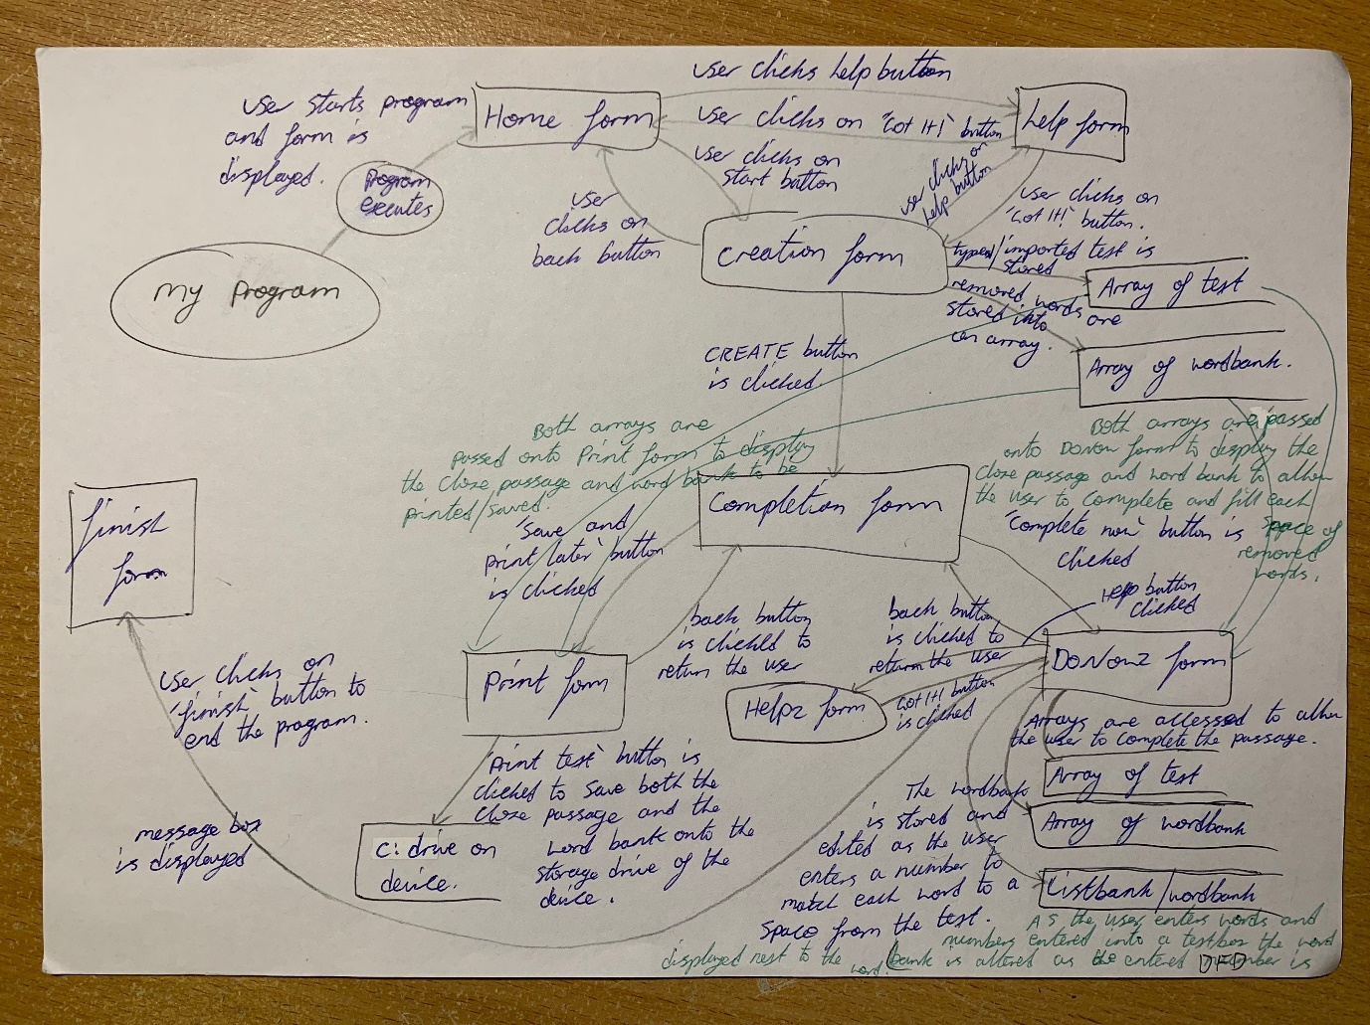

**Screen layout diagram**

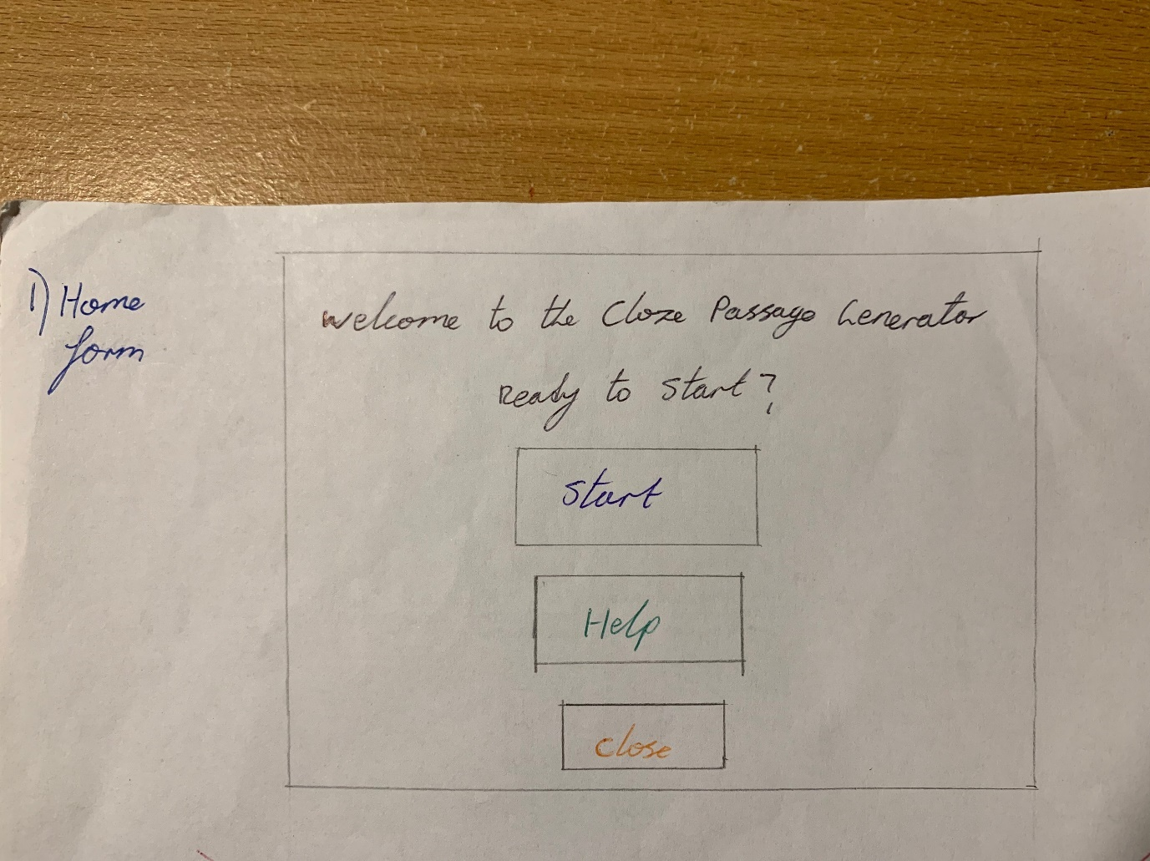

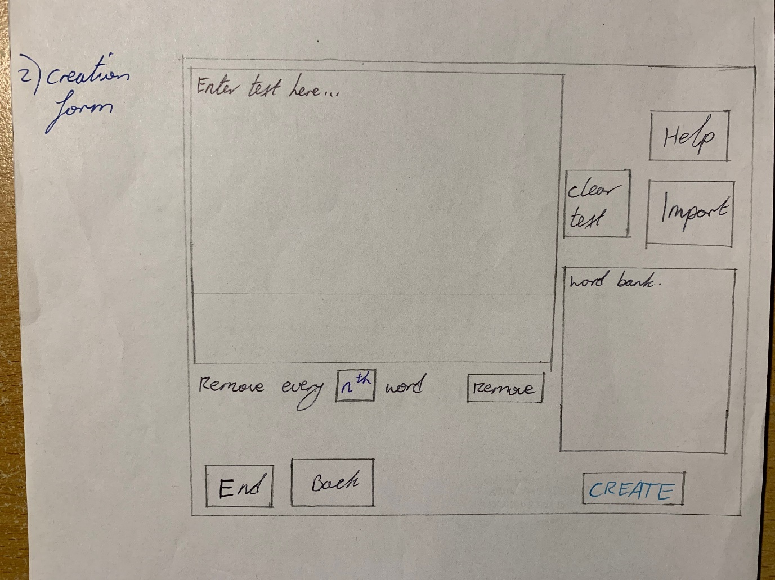

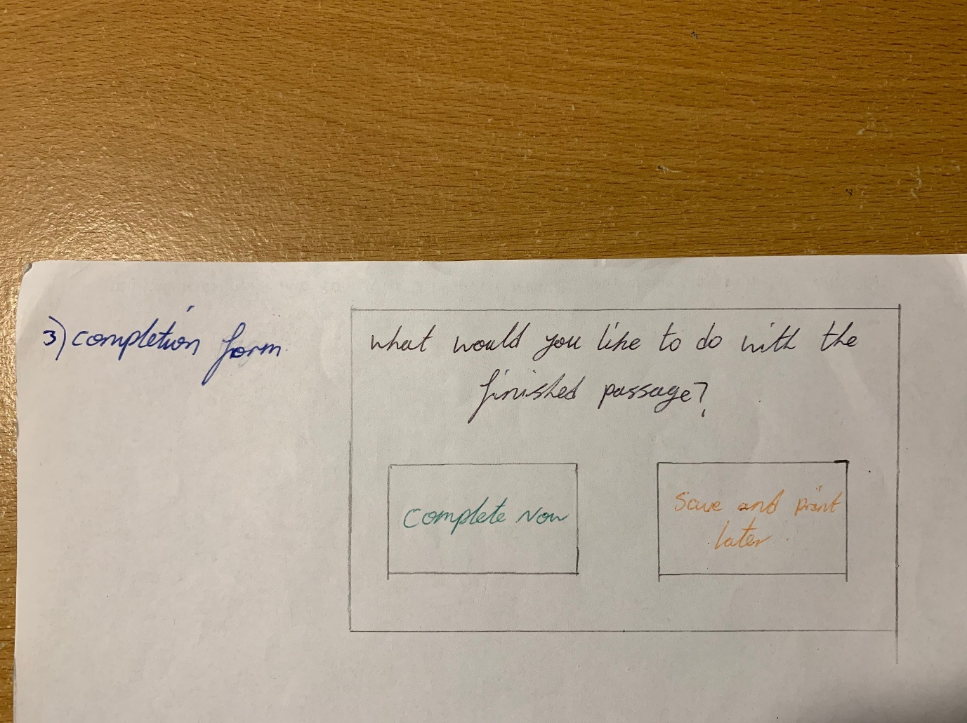

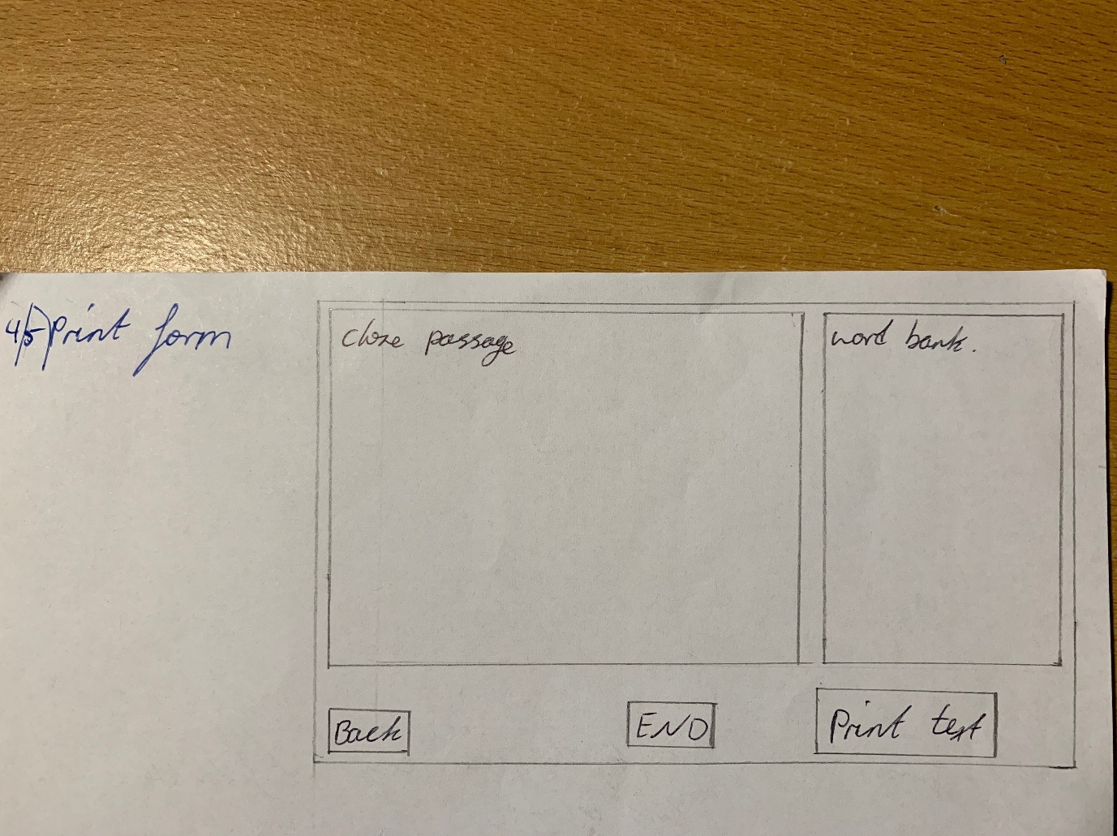

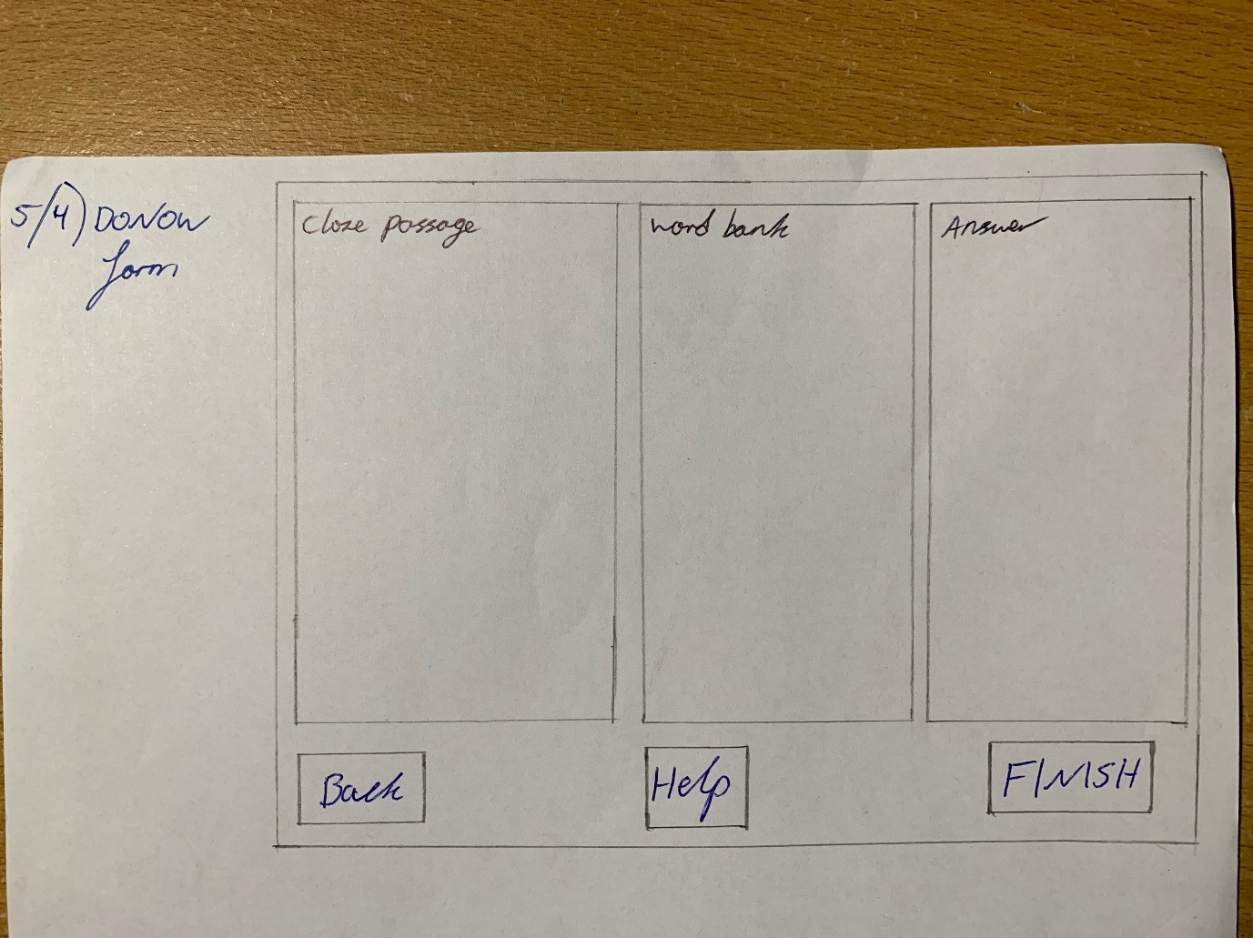

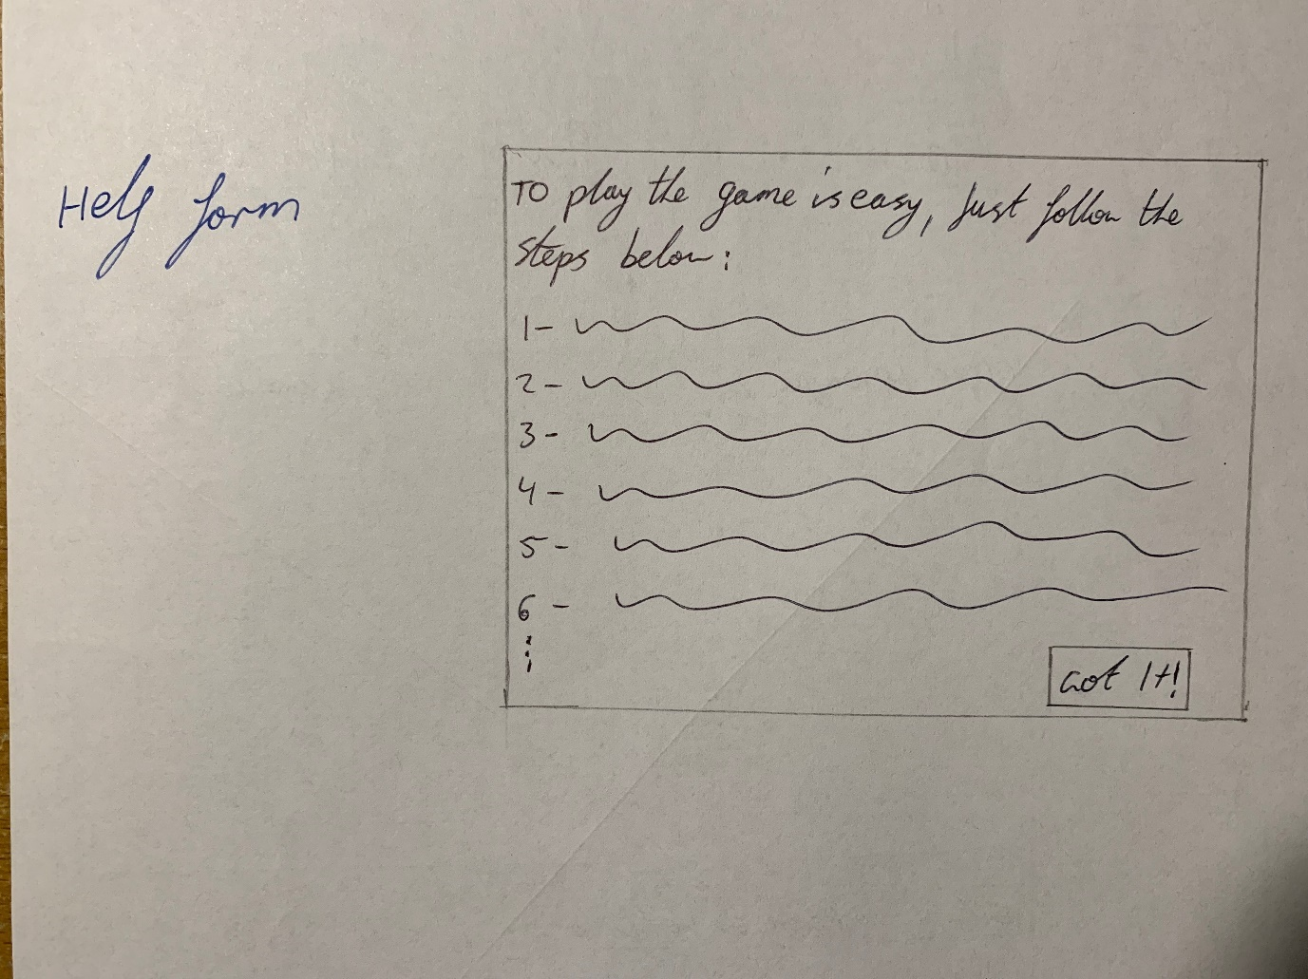

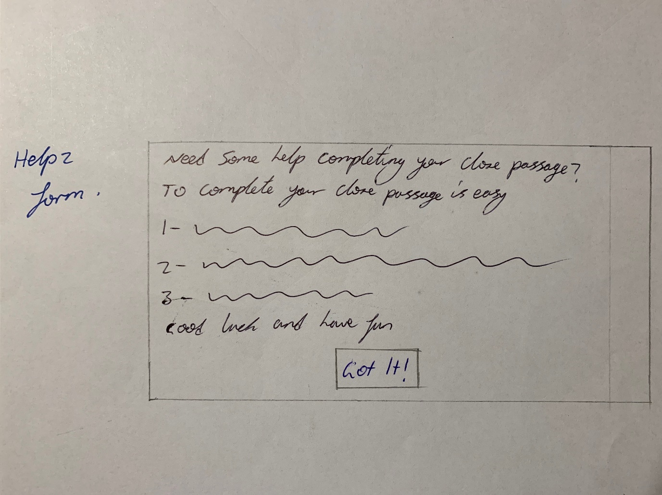

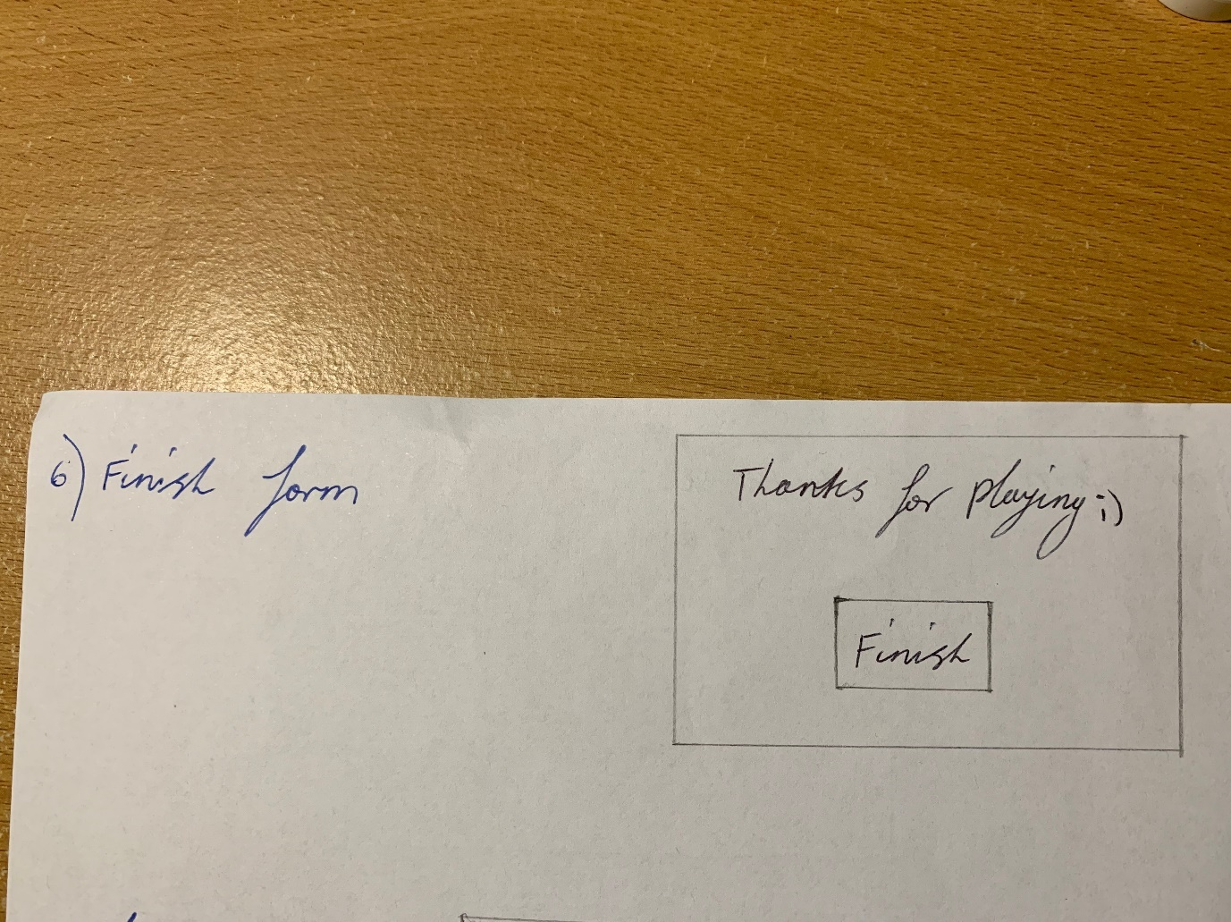

**IPO**

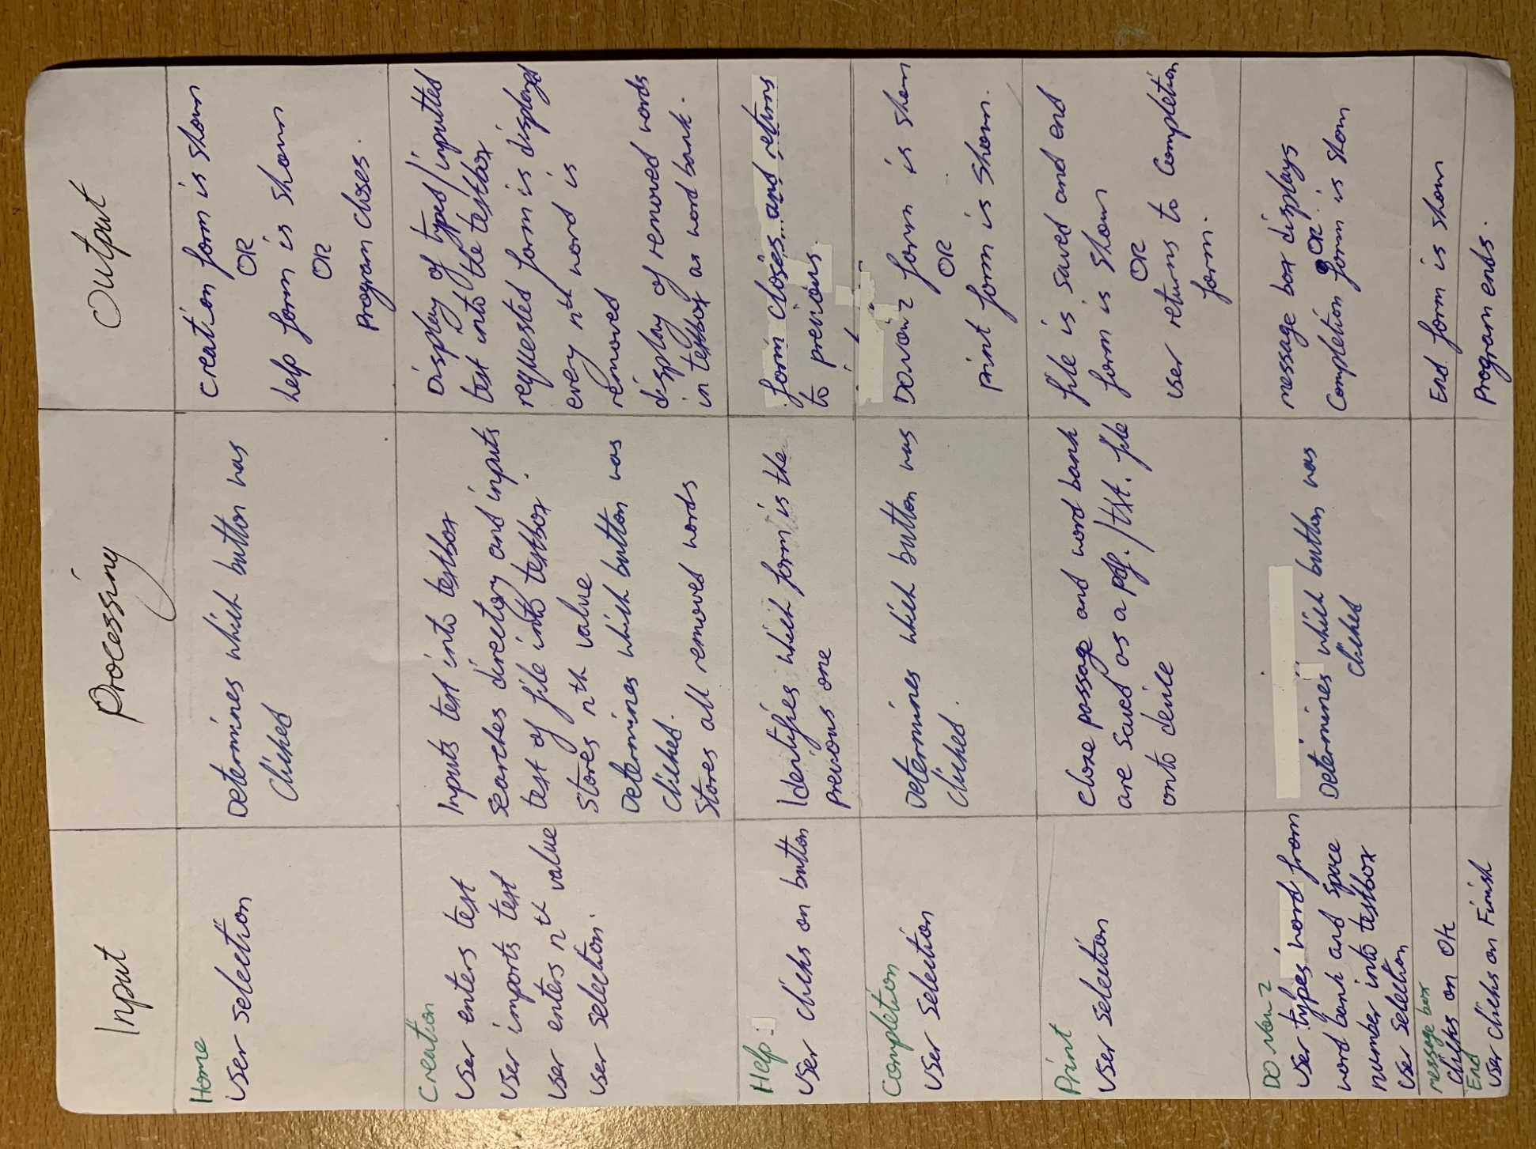

**Storyboard**

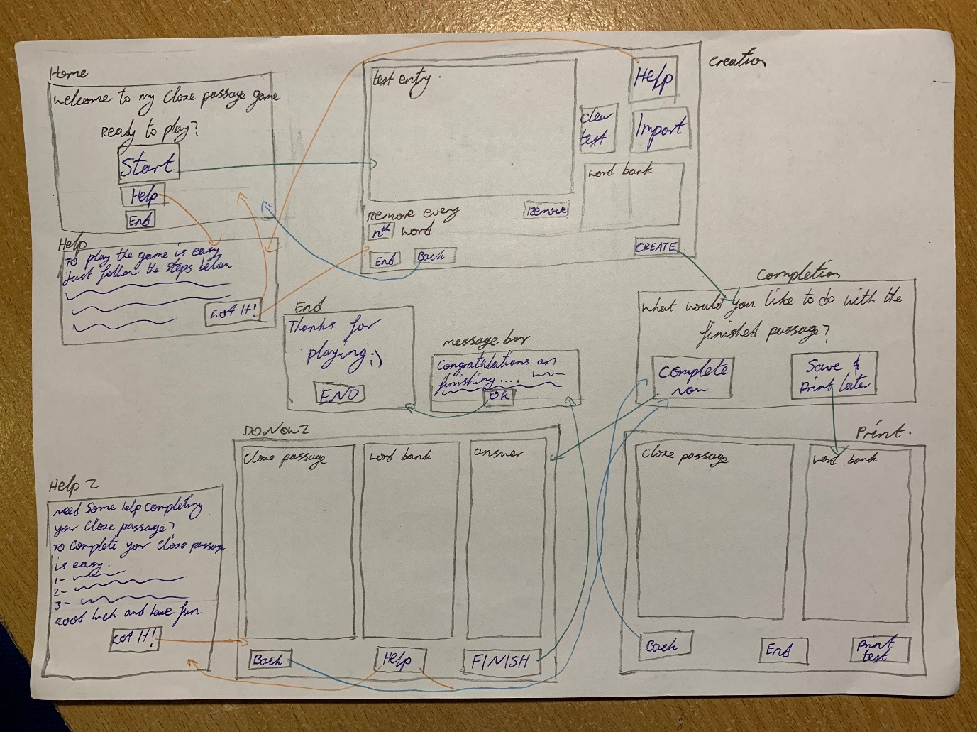

**Testing of Algorithms and Detailing of why each test data was used**

**Assessment of program**

**Use of any standard modules**

I haven’t implemented any standard modules within my program to avoid confusion and difficulties which may persist when using modules. Instead, I’ve kept persistent to private subs which control elements displayed throughout each form such as textboxes and buttons.

**Choice of programming language**

I have decided to use Visual Basic as the programming language for this project as I understand this language the best compared to others such as Python or C#/+. Visual Basic also allows for object orientation with simple and easy alterations to be made to the layout of the programs interface.

Each form can be linked to each other through buttons and various functions can be easily implemented and each element within each form can easily be programmed to perform desired functions such as display message boxes, move to another form or remove words and display them within a textbox.

**Sorts and searches implemented**

I have implemented a linear search within my program to search for every nth word within a body of text which is then entered into a Rich Textbox. This textbox is then made a global variable to be accessed by other forms to display the cloze passage and word bank. This is the only search I have implemented into my program which stores all removed words corresponding to the *n*th value from the body of entered text into an array. This array is not sorted or shuffled as I have not been able to implement this code into my program.

**Data types and structures used and why**

I have incorporated numerous data types and structures into my program for numerous reasons ranging from requiring that specific data type to enabling special functions and allowing for a more user friendly and logical program. The different data types that I have used include:

* String; the text entered into the textboxes by the user and the program use string data types to store the data.
* Boolean; the data used to determine which form the back button returns to within the Help form as either the Home or Creation form.
* Integer; the word counter within the Creation form and the indexes within the arrays are all stored as an integer data type.

The different structures I have implemented include:

* Split; this allows the text entered/imported into the textbox to be used to create the cloze passage within the program to be stored into an array where each word is saved into each index and can be called on to remove specific words which are multiples of the entered nth value.

# Implementing Software Solutions

**Appropriate Design Methods**

**Development approach**

I have decided to use the Agile development approach as this will allow better flexibility to change and will produce a working version quickly within the time-frame given. This approach will allow for easy changes and adaptation to be made during the development stage.

**User interface**

I have ensured to present an intuitive and clear display for the user to follow as they progress through my program. I have included text within each textbox to indicate what must be entered and made buttons and their labels clear for easy navigation. All elements of each form have been made as clear as possible of its function as to indicate its necessity for appropriate use of the program and its position within the form. Each element within each form has been designed to optimise user friendliness and ease of use throughout the progress of my program from start to finish.

**Elements on each screen and justification**

Within each screen there are directory buttons and textboxes that allow the user to progress through my program and create a cloze passage from within the program itself. I have designed large buttons with clear simple text to make it easy to identify what each button does and where each can be found. This is to allow for ease of use as well as user-friendliness. Below is a list of the different elements I have used and, what they do within my program:

* Textboxes; allows the user to enter the *n*th value to remove the desired words from their entered body of text.
* Scroll bars; displays a scroll bar within rich textboxes when the text displayed is too long and allows the user to scroll up or down to view the text within
* Command/Buttons; placed throughout my program to provide navigation to other forms and perform functions such as saving the cloze passage and word bank, removal of words, importing of text and the clearing of text from rich textboxes
* Rich textboxes; used in numerous forms to allow text to be entered to imported, to display the cloze passage and word bank and allow for completion

**User Manual**

Refer to the User Manual document to view

**Online help**

I have implemented two help forms within my program which provides the user with instant help on how to use my program to create and complete/print a cloze passage. Once the user clicks on the help buttons located on the Home, Creation and DoNow form they will be taken to a help form to understand what to do to create and complete their cloze passage. The DoNow form has a unique Help form directed to/from it which instruct the user in how to complete the cloze passage, whilst the Home and Creation form have another Help page which directs how to create their cloze passage within the program using the functions displayed.

**Test data**

I have decided to use 2 different documents for testing the functionality of my program by importing them into the textbox. These text files used include large sections of text with punctuation marks such as full stops and commas. The 2 files I have used consist of a smaller paragraph of text and a practice essay including 300 words.

# Testing and Evaluating Software Solutions

**Assessment of Final Solution**

**Reflection**

Throughout the course of this assessment, there have been numerous obstacles and difficulties faced that had to be overcome to reach a satisfactory completion. Majority of these complications occurred within the implementation stage of development whereby the program had to be coded in Visual Studio. Such complications include the difficulty present when understanding and coding a split function, removal of words, declaring the word bank and cloze passage as a global variable and when coding the printing function. Other challenges relate to the documentation for this project and the difficulty in completing the criteria for each diagram, mainly concerning the algorithm and Deskchecking sections which were time-consuming and required an in-depth understanding of my code. Overall, this assignment has been challenging but I have been able to successfully develop a program that satisfies majority of the criteria with full documentation to support. I could’ve implemented some additional features to improve my program and its functionality but ran out of time and lacked the expertise to code such features such as the shuffling of an array, the correct completion of the cloze passage, the checking of answers and providing successful implementation of the printing function to save a pdf. file which accurately represents what is displayed within my program in the Print form.

I acknowledge the use of sources such as stackoverflow.com.au to docs.microsoft.com to find solutions to problems and conduct research to create a better more efficient program. I have used these 2 sources as majority of this assessment.

**Desk check**

*DoNow2 form*

|  |  |  |  |  |
| --- | --- | --- | --- | --- |
| **Rtbbank** | **rtbtext** | **Creation.bank** | **valu** | **Output** |
| are | Hello how are you | are | 0 | Cloze passage with words removed and word bank in 2 different textboxes  Hello how ___ you |
| = | = | = | 1 | = |
| = | = | = | 2 | = |
| = | = | = | 3 | = |
| = | = | = | 4 | = |
| = | = | = | 5 | = |

*Completion form*

|  |  |  |  |  |  |  |  |  |  |
| --- | --- | --- | --- | --- | --- | --- | --- | --- | --- |
| **Import** | **Bankarray()**  Removed word/s | **Rtbenter**  Text within rtbenter | **Count**  Length of temparray | **Nth** | **Temparray()**  Storage of entered words | **Text** | **Count** | **Text** | **output** |
| Hello how are you | are | Hello how are you | 4 | 3 | Hello  how  are  you | Hello how are you, 4 | 1 | Hello how ___ you | Display of impoerted/entered text within rtbenter  Editing of text to create a cloze passage with removed words and blank spaces and the word bank  Hello how ___ you  Repeats until length of entered text is assessed and all words are removed, stored and displayed successfully |

**Use of test data**

Within the desk check I have used a very small sample of text consisting of 4 words to simulate the processes of my program and determine its success/failure when executed using larger bodies of text. I have extensively used alternative test data throughout the assessing of my program to ensure its full functionality that meets the criteria and does as intended reliably. This test data includes a small sample of random text consisting of words and punctuation as well as a longer sample of text which exceeds 250 words. Both text work within my program to be converted into a cloze passage. I have assessed my programs ability to edit large and small bodies of text, remove all words within a small body of text and input an *n*th value large than the text to evaluate the reliability and build quality of my program to avoid breaks or crashes.

# Journal

**Thursday 02/05/2019**

Today I received the assessment task and broke down what was to be done and thought about how it was going to be done and what the final solution is expected to do.

After school I deconstructed the assignment to figure out what needed to be done and did research on how to code some components as well as designed a rough sketch of the screen layouts.

**Friday 03/05/2019**

During the SDD class I began working on my initial Gantt chart to visualise the time frame I was working with prior to completing this assignment. This Gantt chart would only act as a guide to inform me of the approximate times it would take to complete each task. My final Gantt chart will be another chart which will display the true time it took to complete each task as I complete them in real-time working towards completion.

**Saturday 04/05/2019**

At home I completed the initial Gantt chart I started in class and created the spreadsheet for the final Gantt chart, so I can edit it as I complete each task.

**Sunday 05/05/2019**

Over the weekend I completed my Gantt chart as well as began designing the user interface within Visual basic by creating each page and programming start, help and end buttons throughout which revert the user to different pages, closes the page and ends the program.

**Monday 06/05/2019**

Today outside of class I began writing out my report in full, including the sub-headings and journal as well as edited my final Gantt chart.

**Tuesday 07/05/2019**

Within my own time I worked on my program by designing the interface of the creation page where the user will be able to import or type text to use to create the cloze passage and alter how many words will be removed and stored in an array to create the cloze passage. I also edited my Gantt chart and worked on my report.

**Thursday 09/05/2019**

Today during the double lesson and outside of class I completed the requirements section of this report, update my Gantt chart and worked on my VB program by editing the coding for the creation page

**Friday 10/05/2019**

I have been very busy within the double period we had where I, completed the entire requirements section of this report, edited my final Gantt chart, drew up design layouts for the pages I’ve designed within VB as well as began to understand how I will implement the coding to create the cloze passage to complete this requirement for my program. This has been difficult as I need to understand what the code needs to do and how I will do this. I have made steady progress and aim to complete the creation page within the next week.

**Friday 17/05/2019**

Within the double period I have been focused on understanding what needs to be done and began thinking of how I will do each task. I’ve worked extensively to progress through the documentation to better understand how the interface, functions and processes of the program will be performed and displayed. I have made notes which list what needs to be done and an idea on how I can do each task as well as made rough sketches to perceive how the interface will be displayed as. I aim to break down what needs to be done for each section of my program to aid in the overall development over the weekend.

**Tuesday 21/05/2019**

Today within my own time I have set about working on my program in Visual Basic by focusing on the creation page where the cloze passage will be able to be written or imported and selected words to be removed and stored in a word bank. I have prioritised the task of making a word count and adjusting what the ‘remove’ button does when its clicked. I have also progressed through my documentation and edited my Gantt chart. I aim to continue working on the program to finish the creation page as well as break down what needs to be done for each form and section of code to better understand how I will satisfy the criteria.

**Thursday 23/05/2019**

Within the double period I’ve prioritised the lesson to work on my program to complete the completion page where the cloze passage is made. In progression I’ve continued to determine how I will implement the function to remove every nth word from the text inputted into the text box, replace each removed word with an underline and display the words into the word bank. I’ve written down the logic of how I will do this and am currently looking into how I will input this into code within Visual Basic. I intend to complete some diagrams over the weekend.

**Friday 24/05/2019**

Within the last few minutes of class and at home I’ve been able to write down and determine the logic required to complete the nth word removal function for my program. I also began working on the social and ethical issues involved within my program by stating which are considered in this report and how. I aim to understand the logic of the nth word removal and code this in my program over the weekend.

**Saturday 24/05/2019**

Today at home I’ve been successful in making the nth word removal functional but with some errors that need to be altered. This error involves the blank spaces to replace words but if the nth value has changed them the blanks are used as words and added to the word bank. I can disable the nth value textbox input after the remove button is clicked to mend this issue. I’ve also completed my storyboard and IPO table for my program. I aim to mend this issue and complete more diagrams over the weekend.

**Sunday 25/05/2019**

During my free time I’ve worked mainly on this report and my journal as well as attempting to fix the issue regarding the nth word removal. I’ve been successful in doing so by disabling the textbox input for the nth value after the remove button is clicked. I aim to progress through this report and complete more diagrams over this next week.

**Monday 26/05/2019**

At home I’ve been able to prioritise my time working on the final Gantt chart. I’ve also been able to progress on my program by designing the user interface of the forms continuing from the Completion form, however, I did encounter an issue where Visual Studio won’t allow me to enter the code for each element on the form. I’ve been able to repair this issue by restarting Visual Studio. To mend the previous issue mentioned in my previous log entry regarding the is nth value removal of text and constant removal I’ve disabled the nth value textbox after the remove button is clicked. Alongside these 2 tasks I’ve also been able to commence work on the quality assurance measures section of this report. Within the next few days I aim to complete this section of my report.

**Wednesday 29/05/2019**

Today I attempted to progress through the coding of my program by completing the DoNow form, which allows the user to complete the final cloze passage within the program with words replaced with lines and a word bank displayed on the side. I intended to make the RichTextBox text in the Creation form to be declared as a public variable which can be called on within the DoNow form. I have encountered a build error which doesn’t allow my program to run so I will need to investigate this and determine why this is happening and how I can mend it. I aim to complete the DoNow form before the start of next week.

**Thursday 30/05/2019**

I’ve focused on completing parts of my documentation to reduce my work load and progress through the writing parts and leave only the diagrams, algorithm and desk check remaining. I’ve completed the assessment of program section of this report by referring to my progress within the development of the code. I intend to continue completing this report and moving on to quality assurance next.

**Friday 31/05/2019**

I’ve continued my progress through the documentation by completing the quality assurance section of my report by typing a sentence for each factor. I will expand on what I’ve written to elaborate how each factor has been implemented into my program. I’ve also advanced within my coding to achieve functionality of the word bank on the DoNow form of my program. This allows the word bank to be made within the Creation form which is then displayed within the next form to allow the user to complete the cloze passage within my program. I aim to complete the diagrams within the next week and progress through my program to display the passage on the DoNow form to allow the user to complete the passage within the program itself.

**Monday 03/06/2019**

Within my free time at home I’ve been able to successfully display the inputted text from the Creation form to display within the Rich TextBox in the DoNow form. However, in doing so I’ve noticed that the text that is displayed is the original text and not the edited text with underlines replacing each removed word. I must rectify this issue soon to move on towards coding the section that allows the user to complete the cloze passage within the program to progress towards completion of this assignment. I aim to complete this section of coding as well as complete some diagrams over this week.

**Wednesday 05/06/2019**

At school during my own time I’ve collaborated with others to amend the issue I’ve experienced with my DoNow form to allow the user to complete the cloze passage within the program. I’ve successfully been able to display the edited text and word bank within the DoNow form. I’ve also completed the draft for my Data-Flow Diagram and attempted to code the section of my program that will allow the user to save the text as a pdf. file into their device.

**Thursday 06/06/2019**

Within the double period I’ve been very successful in completing numerous components of my program including, numbering each underline that replaces each removed word and implementing a print function. However, I require to import the cloze passage and word bank into the Rich Textboxes found within the Print form to save the proper cloze passage. Currently I can input my own text into the Rich Textboxes and save this but am unable to use the edited text imported/typed within the Creation form. I’ve also attempted to implement the coding necessary to allow the user to complete the cloze passage within my program by including 2 textboxes into which the user can enter the word and space number to match each word to the correct space within the cloze passage. I aim to mend the issue related to the printing function and Creation form as well as use the numbering of spaces to enable the user to complete the cloze passage from within the program and complete more of my documentation by next week.

**Sunday 09/06/2019**

During my own free time I’ve set about vastly editing my final Gantt chart to accurately represent my progress through each section of this assignment as well as edited this report. I still require to do many tasks listed within my Gantt chart before I can alter it to represent my progress. I aim to complete numerous diagrams and other sections of this report over this long weekend as well as continue working through the coding of my program.

**Monday 10/06/2019**

On the last day of the long weekend I’ve been very busy to complete the Data-Flow Diagram and Data Dictionary as part of this documentation, editing this report and the Gantt chart as well as progressed through my coding to provide proper functionality to the DoNow form of my program.

**Tuesday 11/06/2019**

Today during the double lesson and within my own time I have been successful in completing the coding for my program by editing the print function and completing the DoNow form, which allows the user to complete the cloze passage within the program. I am very proud of my progress today. I have attempted to fix the print function to work so that all text is displayed in a single line which I haven’t been successful in but rather decided to leave it as is considering the function works and satisfies the criteria of being able to do so and moved on to coding the DoNow form. I have implemented a new DoNow form which has a new interface with 3 rich textboxes and another Help form. The new interface displays the cloze passage and word bank and allows the user to enter a word from the word bank and the space number from the cloze passage to ‘complete’ the passage within the program, thus satisfying the criteria. Now I prioritise the completion of documentation to finalise this assessment before the due date.

**Wednesday 12/06/2019**

Today at home I decided to refine the user interface by implementing backgrounds and colours on buttons to indicate what should be done and which functions are significant within each form by directing attention to buttons such as Import and CREATE. I focused on aesthetics today to complete my program officially. I must re-do my DoNow form user interface design as I have made changes to it. Tomorrow I intend in completing my user interface for the DoNow form, the algorithm, starting the desk check and completing the user manual.

**Thursday 13/06/2019**

The day prior to submission I have been very busy to complete all sections of this assignment. Considering I have completed my program I can now prioritise all my effort to complete the documentation. I have been successful in completing my algorithm and user manual today. I had to re-do my storyboard, IPO, user interface designs and edit my DFD to tailor for the changes I’ve made since I finished my program as well as take pictures of these diagrams to input into this report and the user manual which I have successfully performed today. I have also started my desk check for the program and will aim to complete this tomorrow during the free and double period at school as well as make any last-minute changes to the report and folder properties (Zipping of folder) prior to the 3PM submission

**Friday 14/06/2019**

Today is the last day to work on this assignment before requiring submission at 3PM through Canvas. I will Zip my program folder and upload each file of documentation separately. Throughout the single free period and double lesson occupied to work on this assignment at school I have completed the desk check for the Creation and Completion and DoNow2 forms as well as edited my algorithm, overall report and user manual, added a bibliography and added to my evaluation in progress to submission.

# Bibliography

* <https://stackoverflow.com/questions/23576469/how-to-shuffle-array-in-vb>
* <https://stackoverflow.com/questions/30413594/how-can-i-add-string-value-and-integer-value-into-listbox-in-vb-net/30413635>
* <https://www.codeproject.com/Questions/461502/Printing-PDF-File-using-vb-net>
* <https://docs.microsoft.com/en-us/office/vba/language/reference/user-interface-help/split-function>

*Note - these are only examples of the resources I’ve used